DESTINY RESOURCES
ADD RESOURCES TO DESTINY
Log in to Destiny
Click on CATALOG
Click on ADD RESOURCE
Leave FIND ALL as RESOURCES
Enter the item you are looking for under WHERE RESOURCE NAME STARTS WITH:
In this example, we typed Chromebook
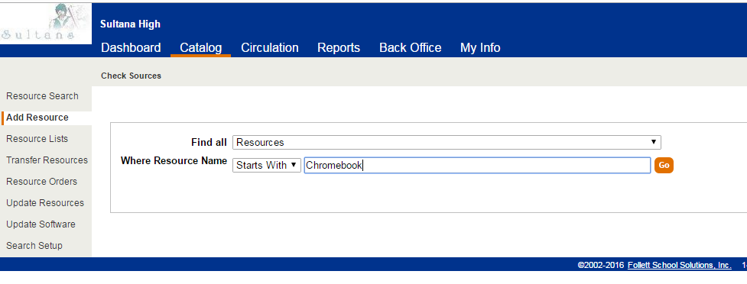
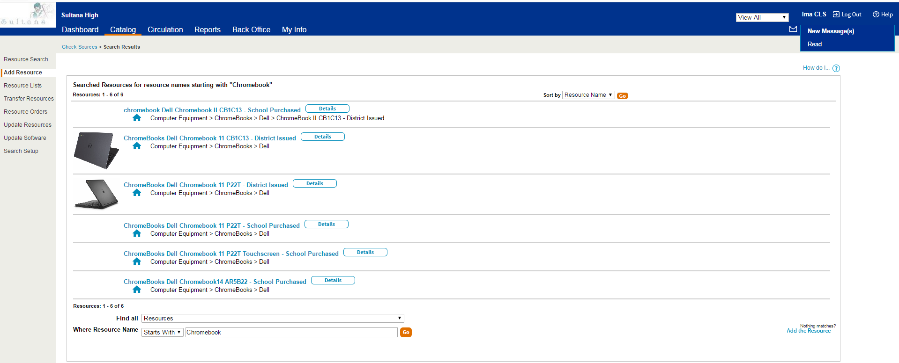
Select the Resource you want to add. Click on DETAILS
To add items to this Resource Type, click ADD ITEM
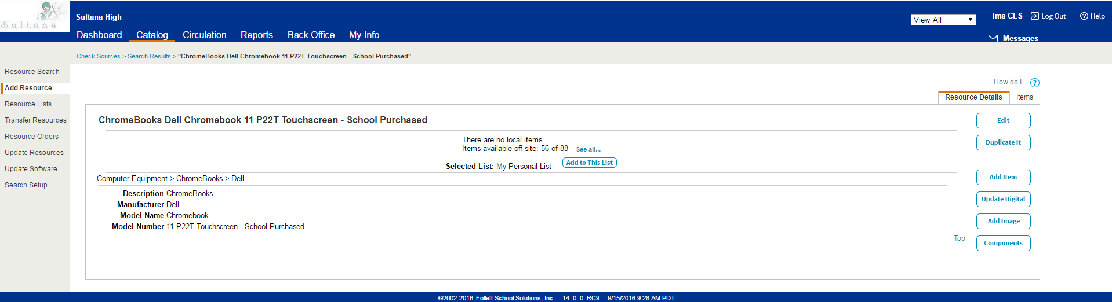
To Add one item at a time, enter the Barcode and Serial Number (See example)
Click SAVE
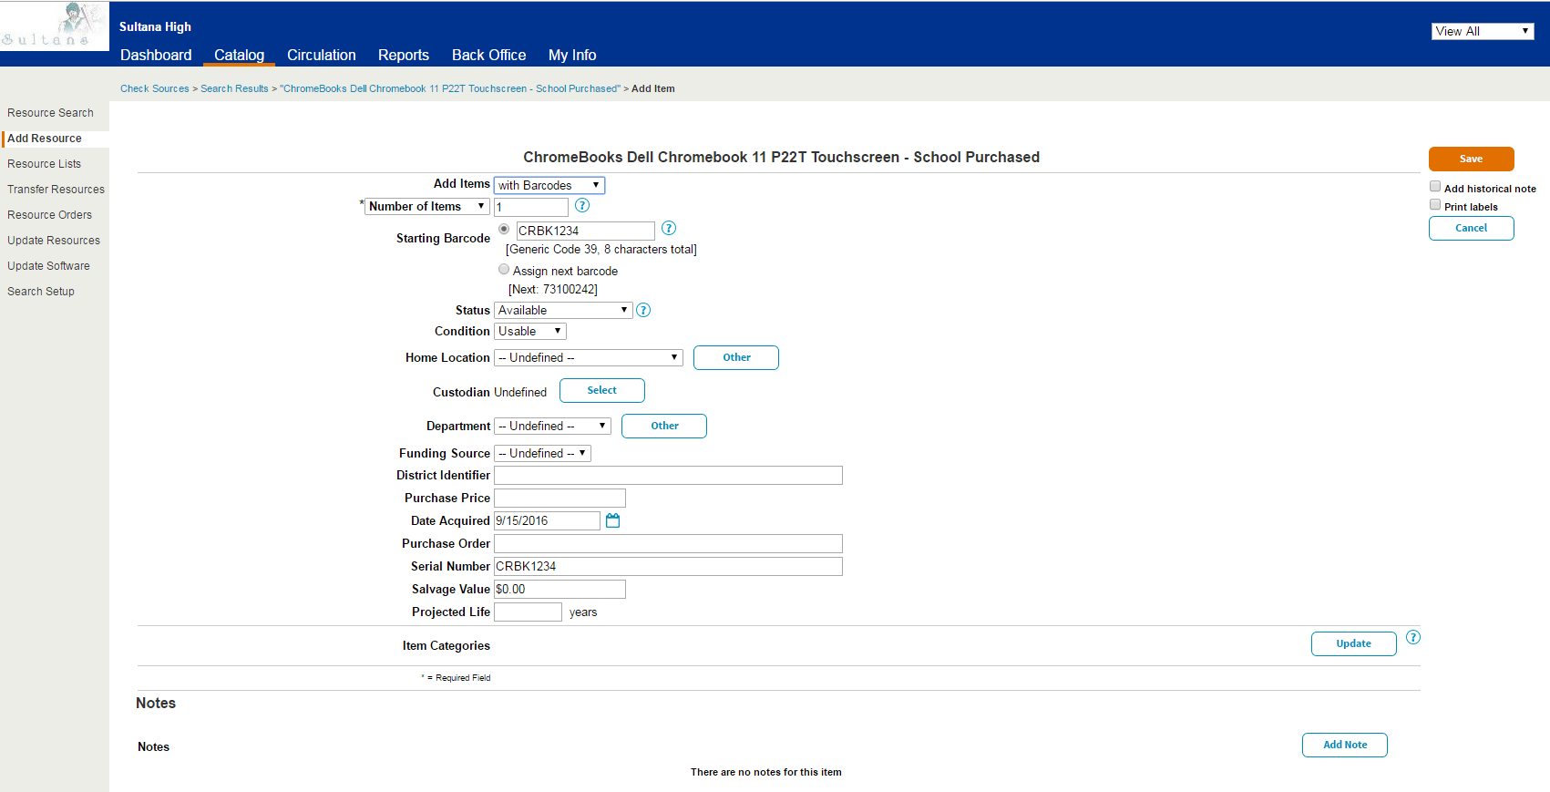
NOTE: You must enter a barcode and Serial Number as a minimum entry. If the item has a barcode tag, use that in the Barcode field, otherwise use the Serial Number for both. All other information is optional, but enter what you have especially when dealing with items that were purchased with Title 1 money.

QUESTION: What if I’m unsure what Resource Name to use?
ANSWER: Click on RESOURCE SEARCH, then click on RESOURCE LIST.
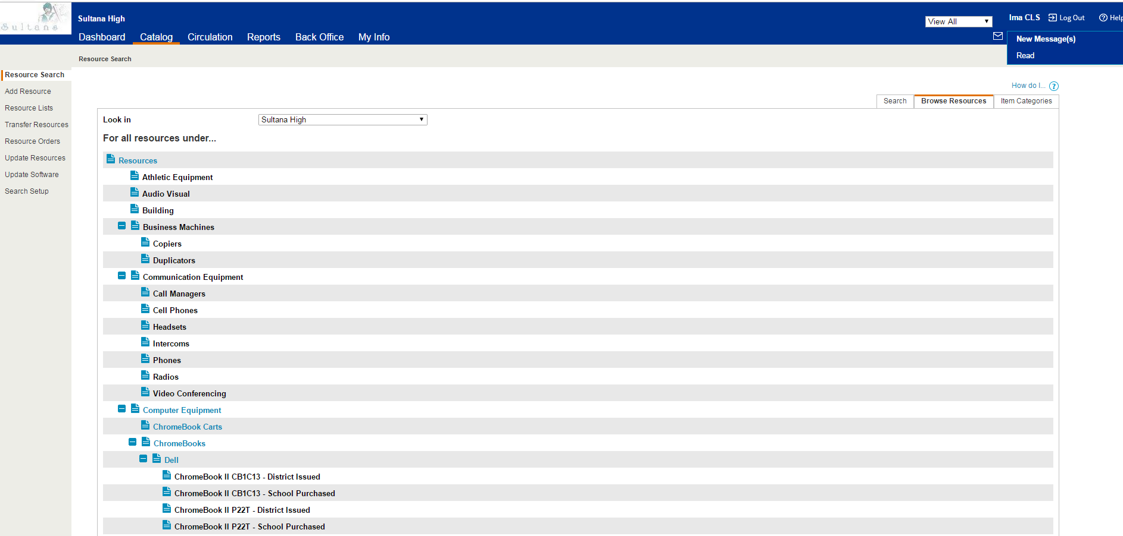

REPORTS
To Run a Report to see which Chromebooks are not checked out.
Click on REPORTS tab, and then select RESOURCE REPORTS
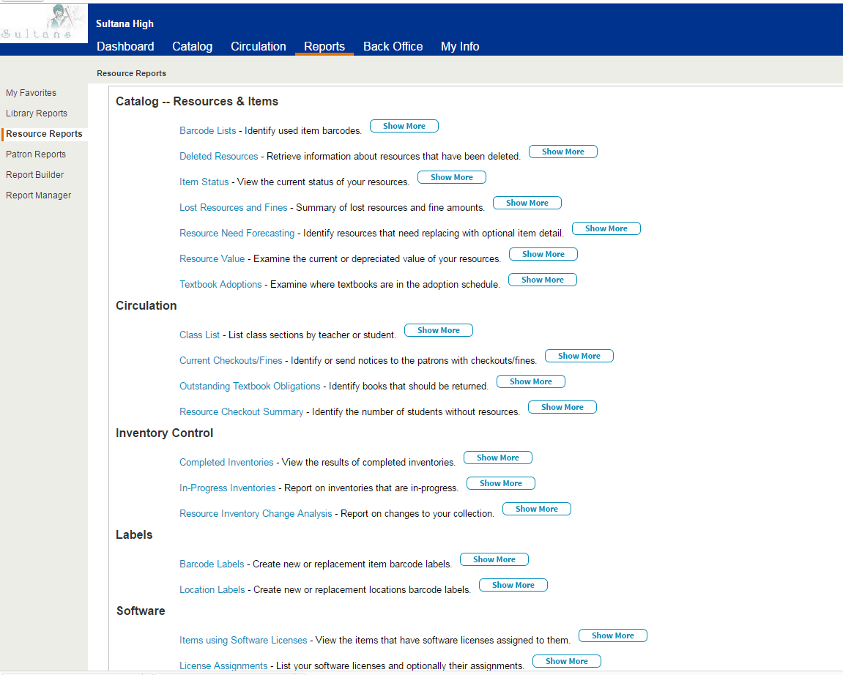
Click on ITEM STATUS
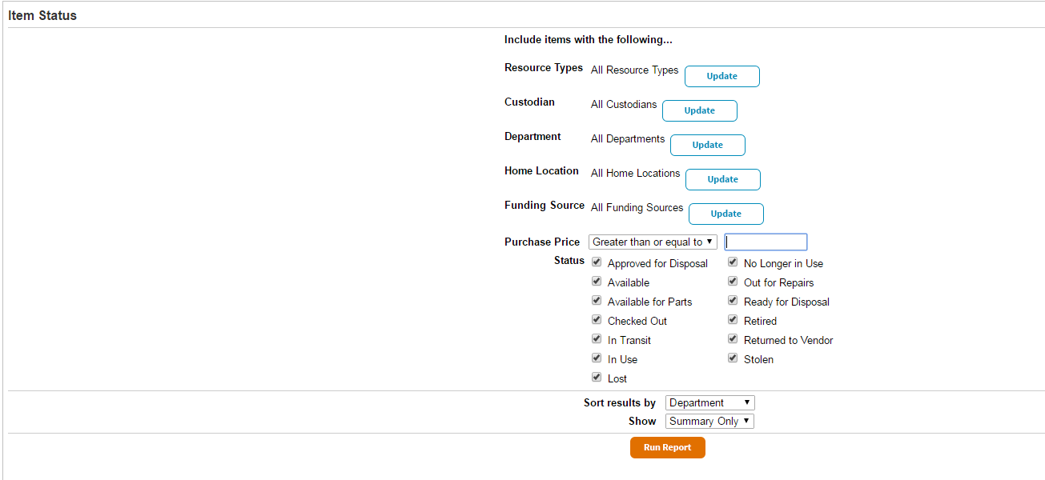
To filter to a specific type of Resource, for RESOURCE TYPES, click UPDATE
Click CLEAR ALL next to RESOURCES, then scroll down to the resource type you are looking for and click SELECT ALL (in this example, we are looking for Dell Chromebooks. We only want to know the number of District Issued Dell Chromebooks, so uncheck the School Purchased and Samsung CB’s.)
Scroll down and Click OK
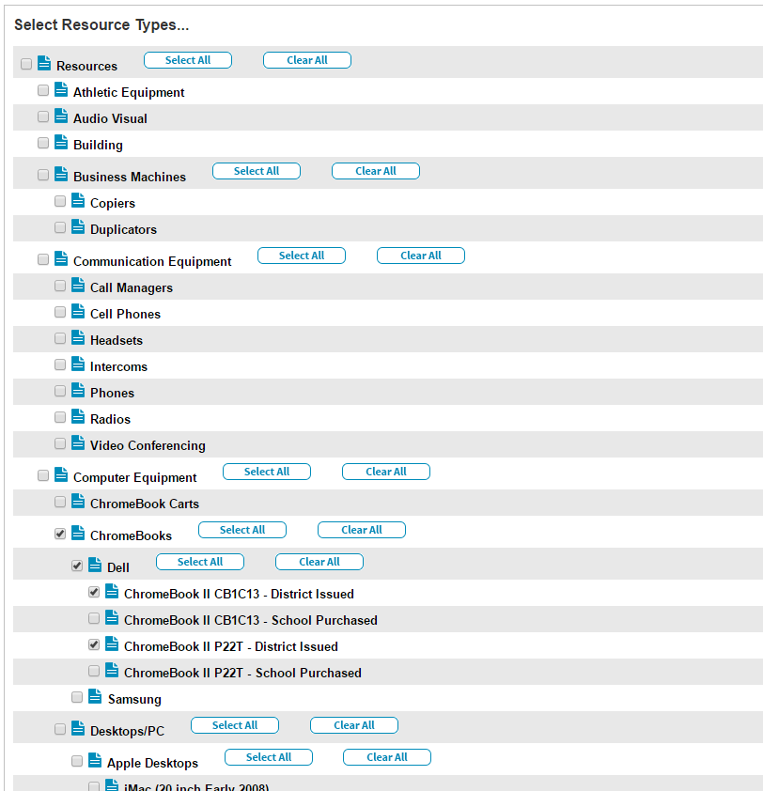
Under STATUS, uncheck everything except AVAILABLE, click RUN REPORT
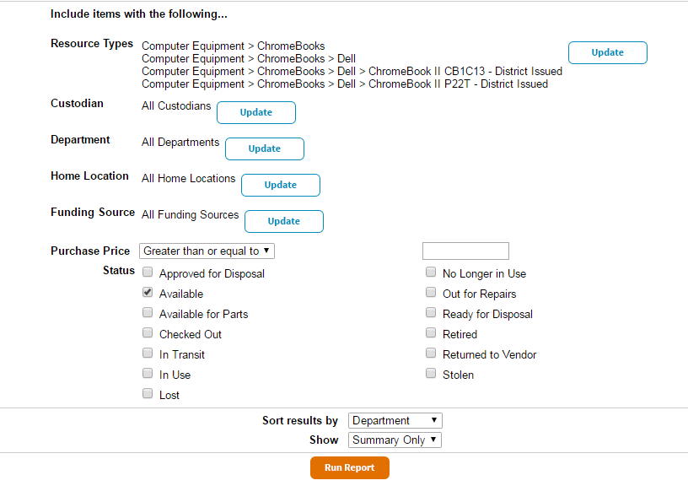
The Job Manager will open, wait a minute or two and click REFRESH LIST, when Completed, click VIEW
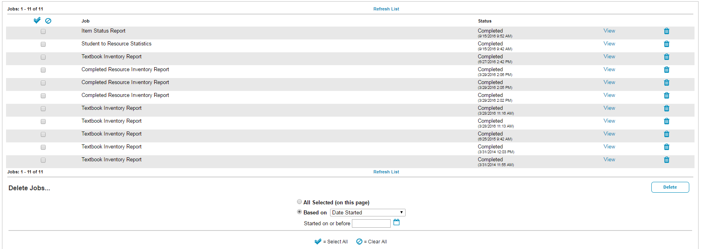
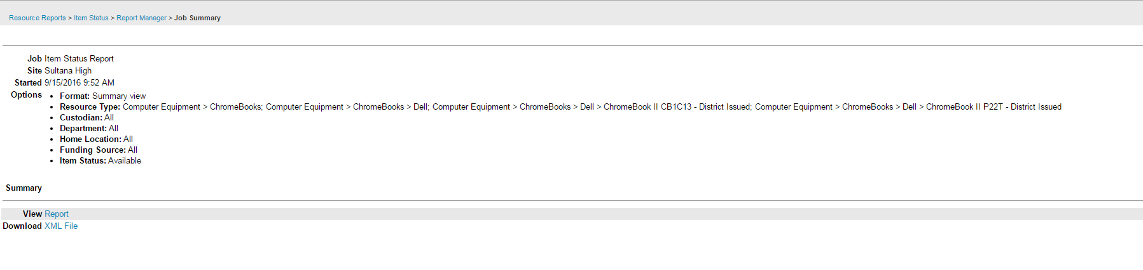
Click on View Report to see results
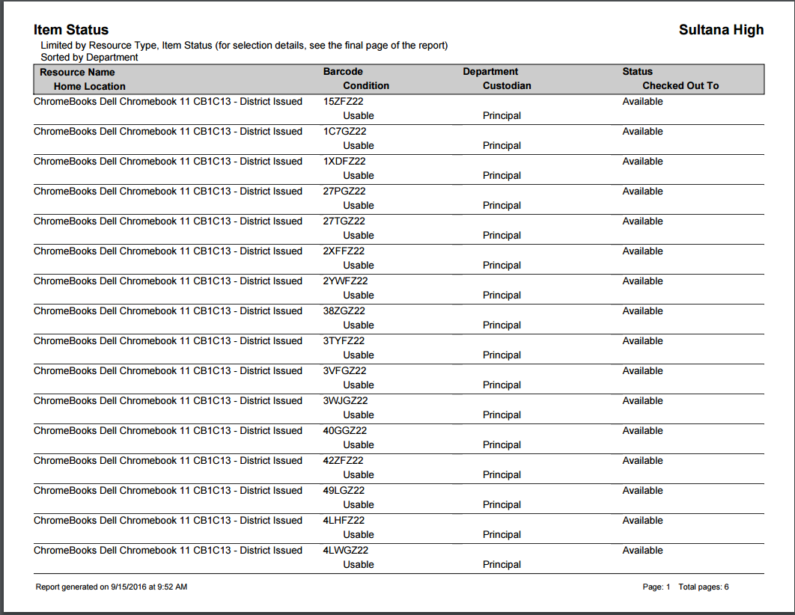
You can also download this report in an XML file that you can open in Excel.
